**Guide for getting your achievements from Steam**

Minimum requirements:

* Access to a Steam account
* A web browser (preferably Chrome)
* (Optional) Rights to install software on your computer, or already having Postman installed on your computer.

This guide is divided in 3 parts:

1. Setting up your Steam account for API access.
2. Installing Postman, a program for API development.
3. Using the Steam API.

# **Setting up your Steam account for API access**

Step 1: Go to <https://store.steampowered.com/>

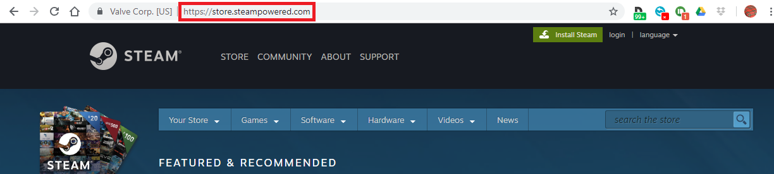

Step 2: Click on “login”

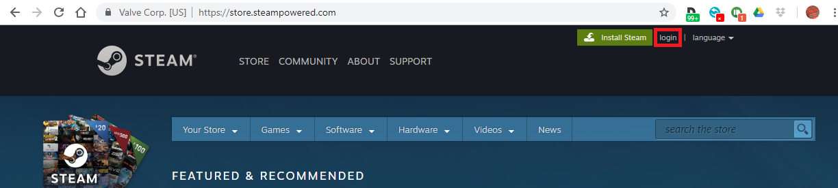

Step 3: Fill in your Steam account name, password and click on “Sign in”

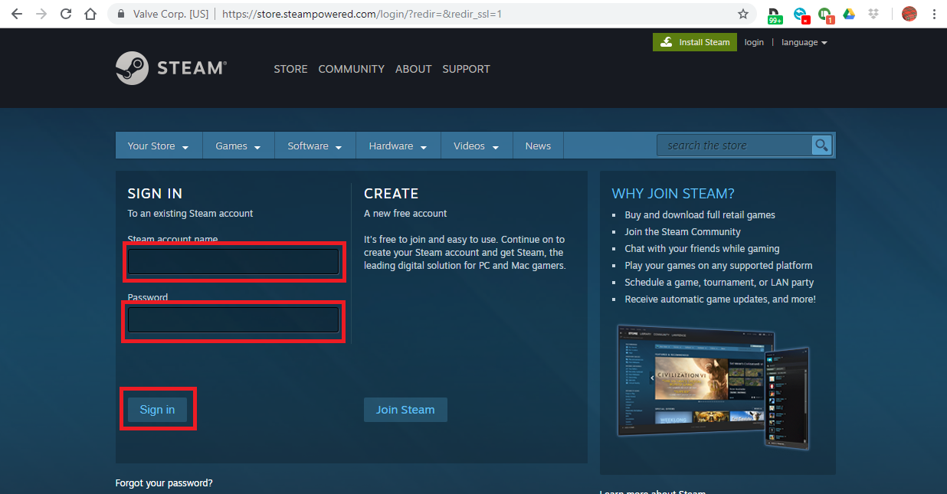

Step 4: Resist the urge to buy 23 new games from the latest sale and instead hover over your username. Then, click on “Profile”

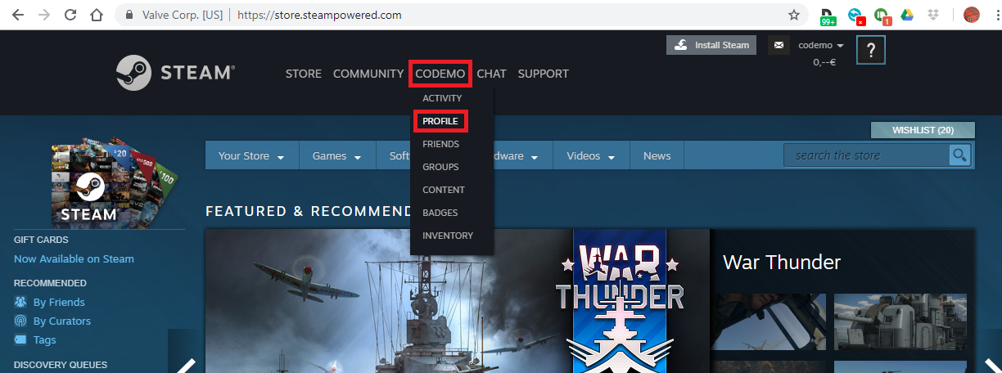

Step 5: Click on “Edit Profile”

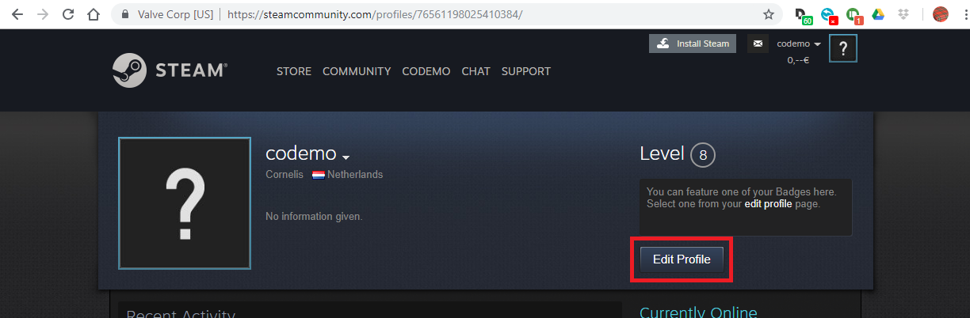

Step 6: Click on “My Privacy Settings”

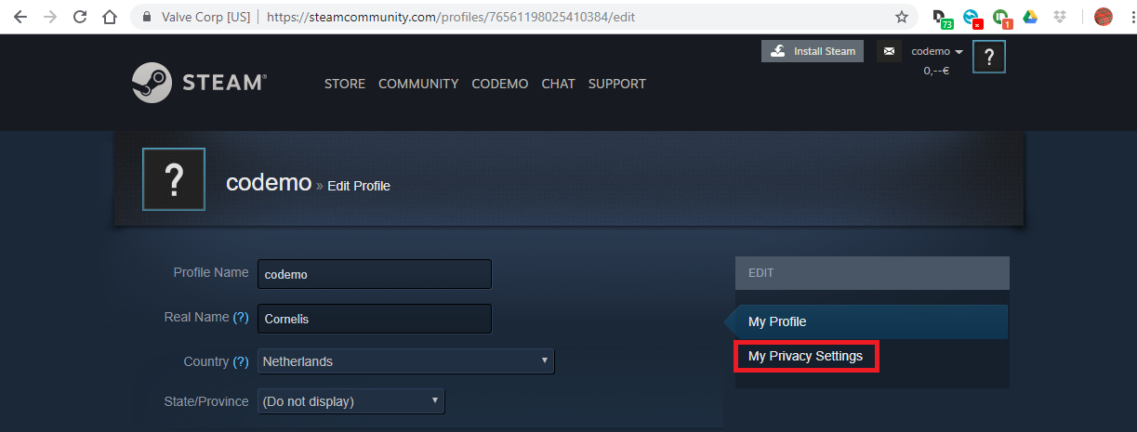

Step 7: Make sure that the following settings are all set to “Public”

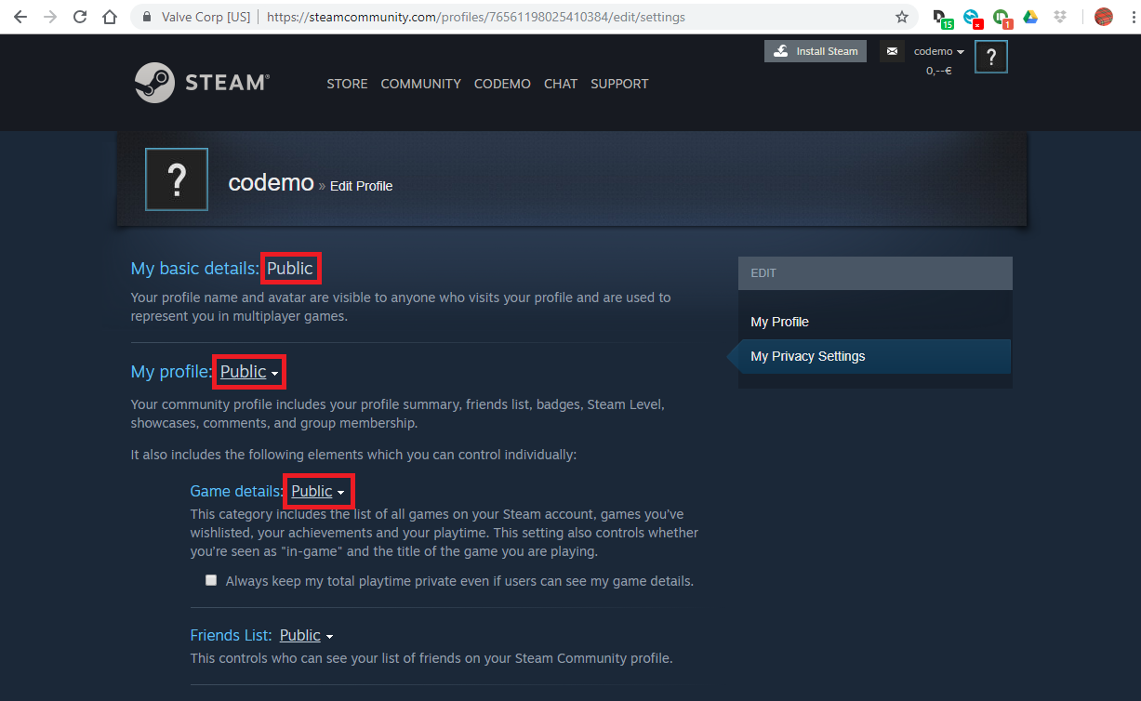

# **Installing Postman, a program for API development**

Step 1: Go to <https://www.getpostman.com/>

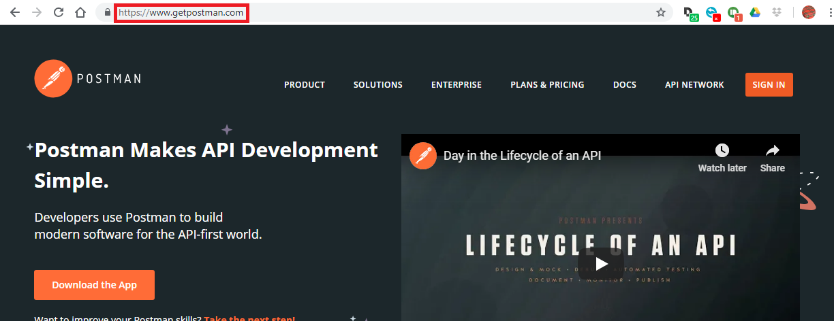

Step 2: Click on “Download the App”

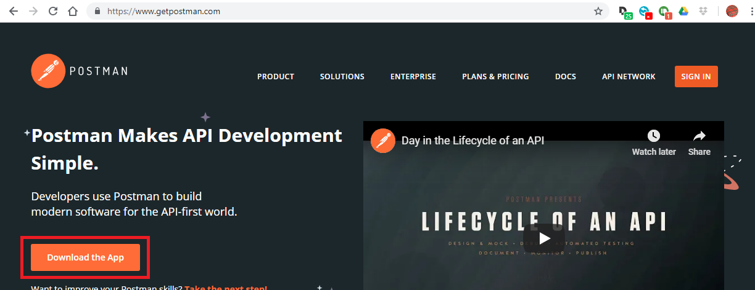

Step 3: Scroll down and click on “Download” for the operating system that you are using (I am using Windows):

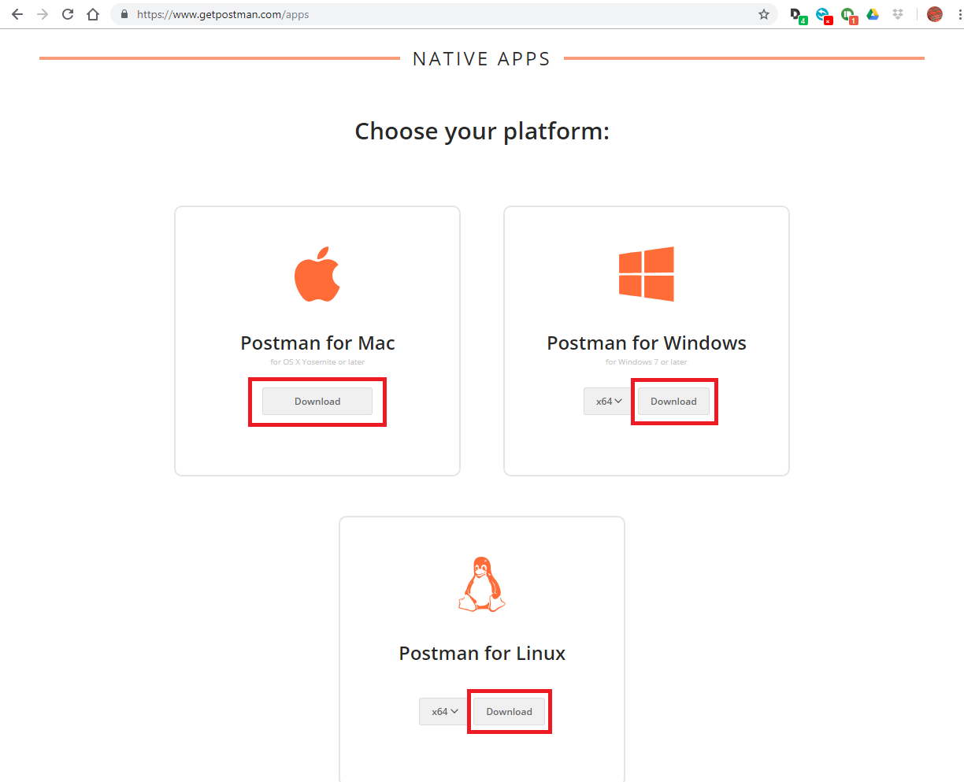

Step 4: A “Save As” screen should appear after a few seconds. Click on “Save”. Remember where you saved the file.

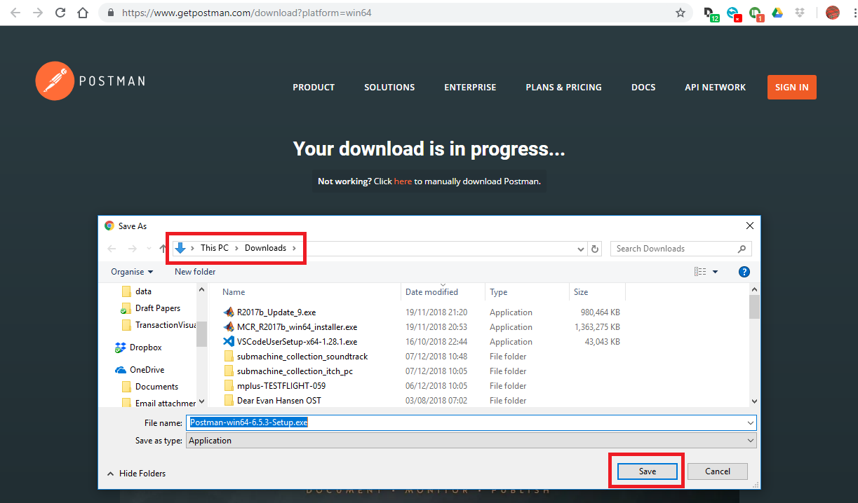

Step 5: Go to the folder where you saved the file and run it.

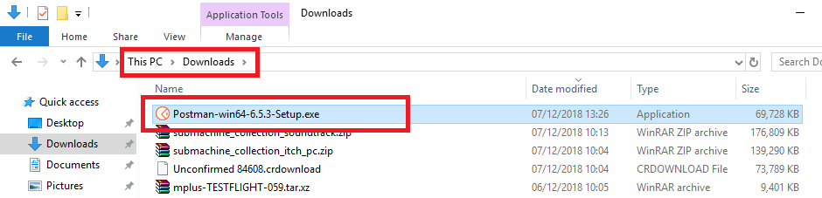

Step 6: Sign in, create an account or skip signing in to go straight to the app.

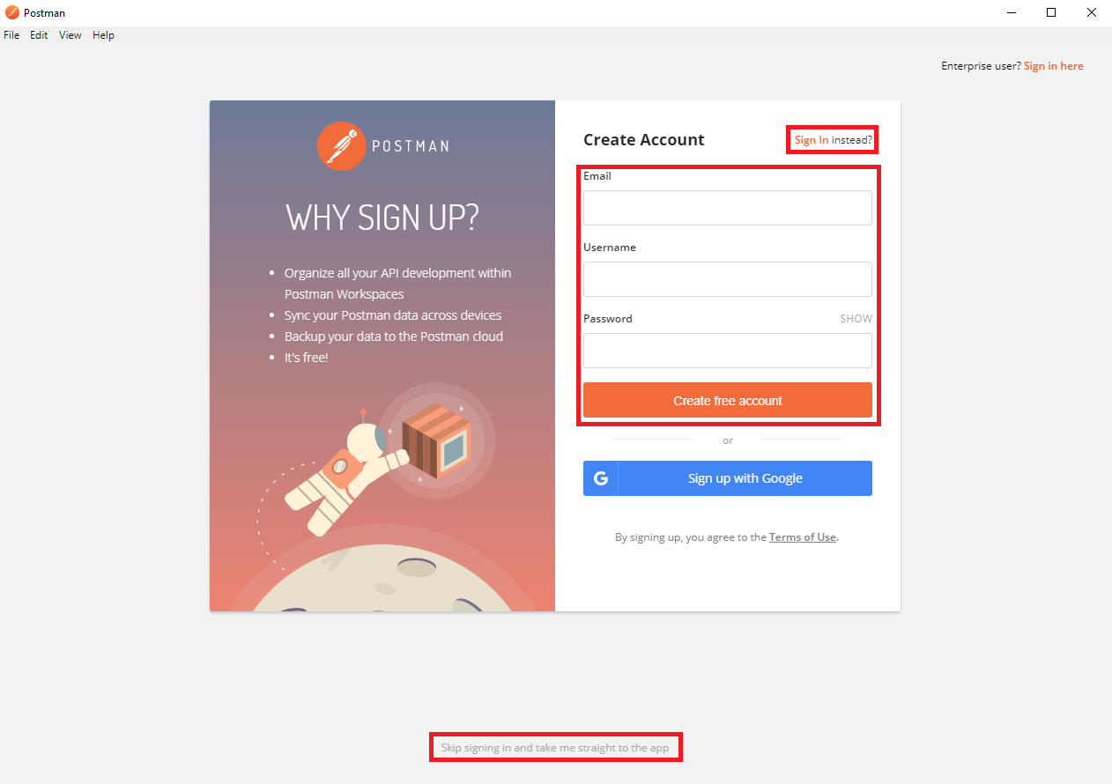

Step 7: Click on “Create a basic request”

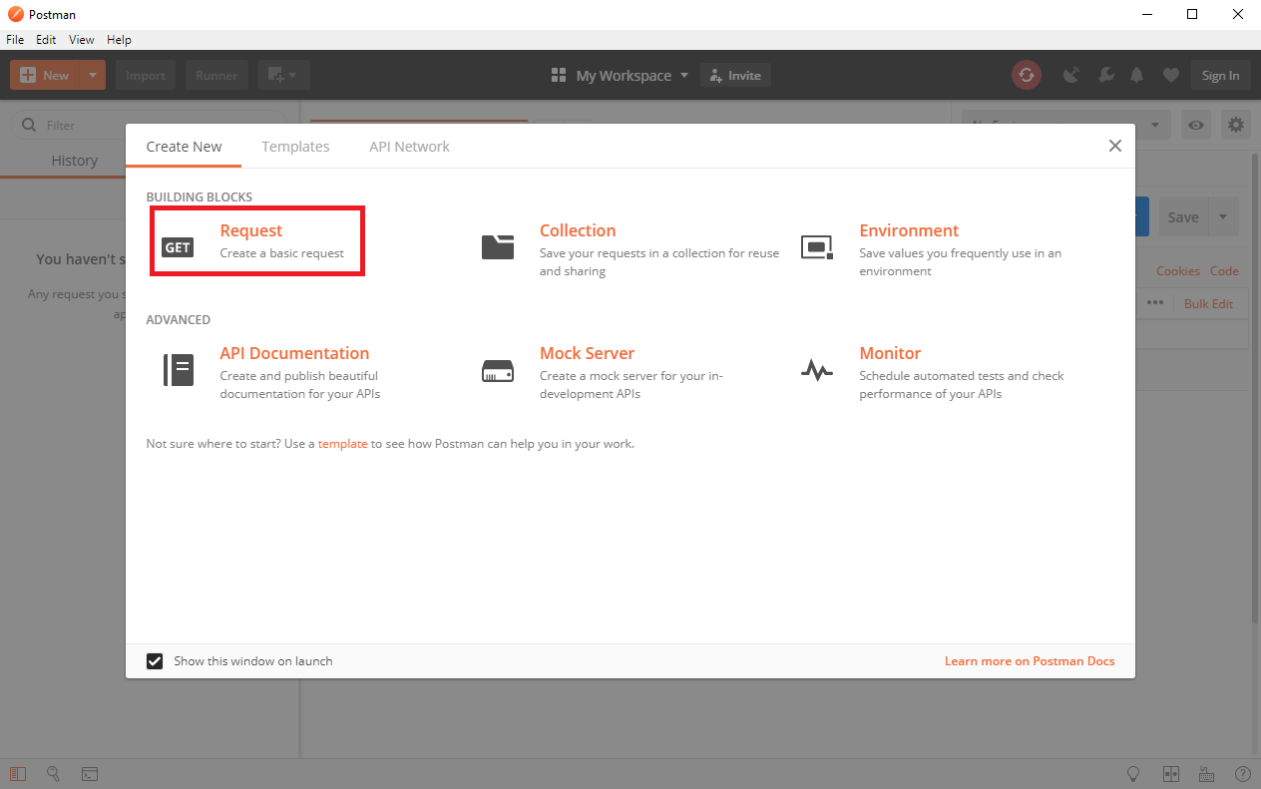

Step 8: Type “Get Achievement” for the request name, type “Steam” for the collection to save to, then click on “+ Create Collection Steam”.

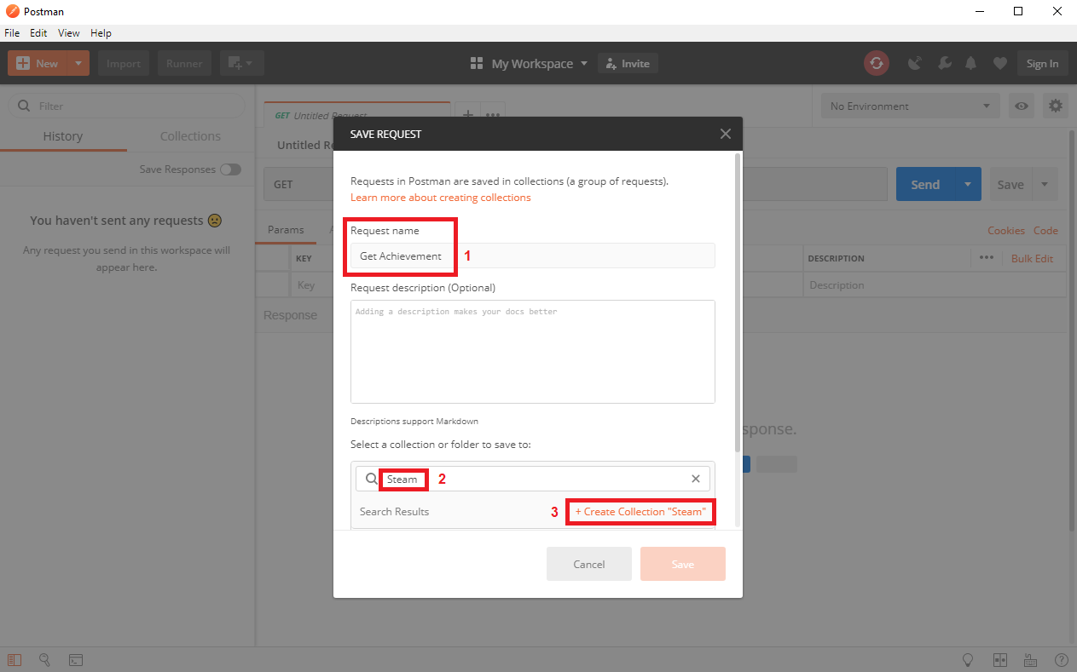

Step 9: Click on the “Steam” folder that you created, then click on “Save”.

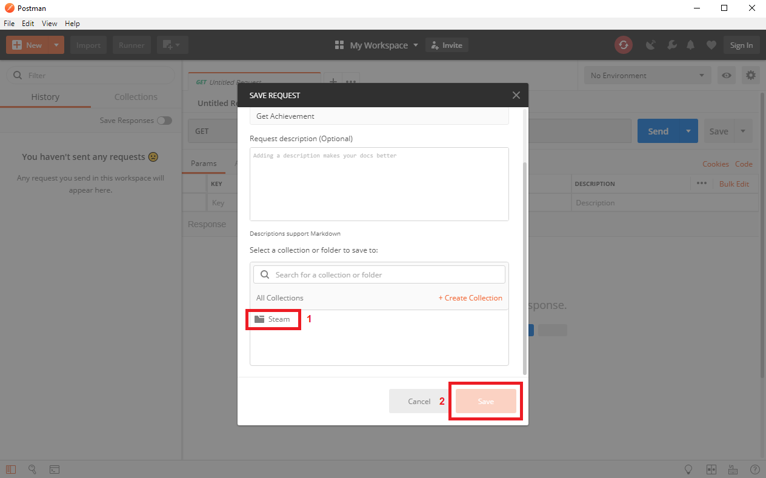

Step 10: You should now see the screen below. You are ready to continue to the next part.

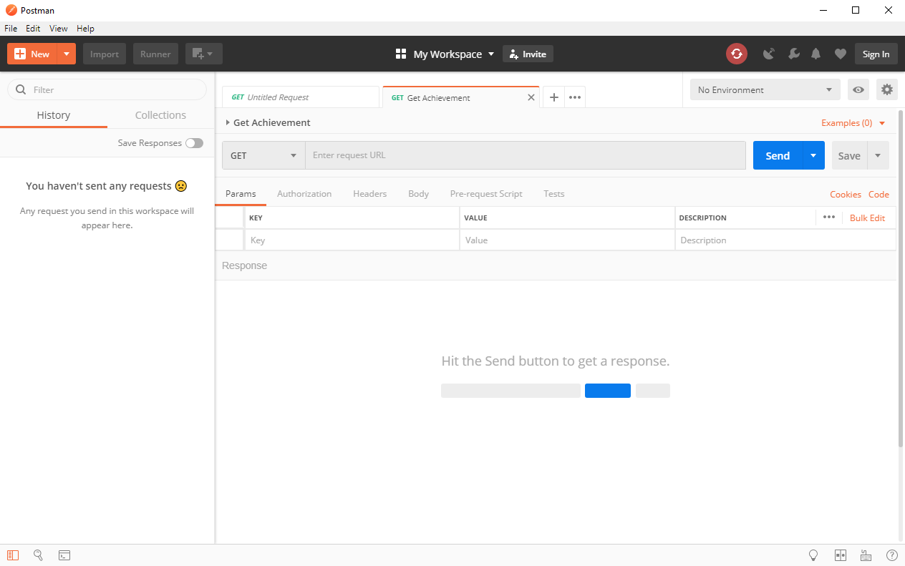

# **Using the Steam API**

Step 1: Go to <https://steamcommunity.com/dev>

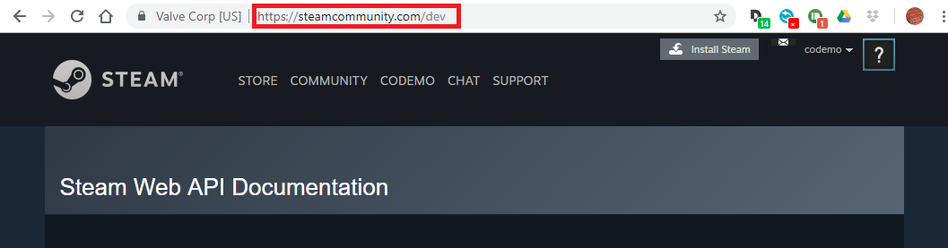

Step 2: Click on “by filling out this form”

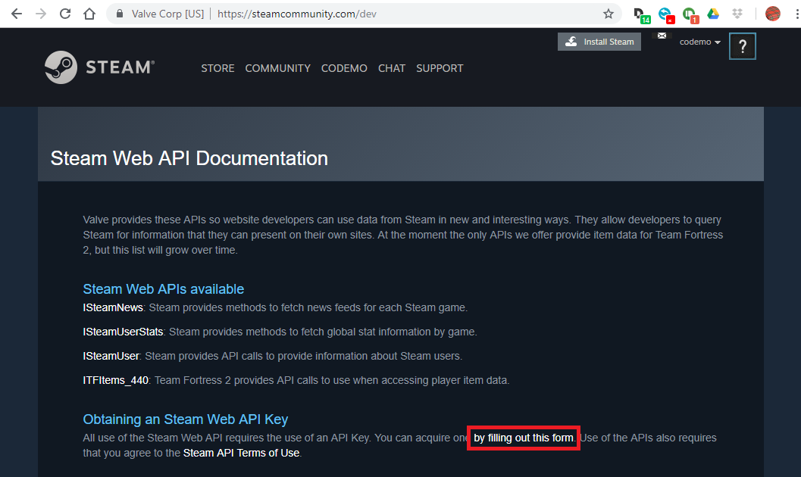

Step 3: A “Steam Web API Key” is needed to access the Steam web API. By filling out the form, you get a free key. You probably don’t have your own domain name, but you can actually fill in any domain name you want: as far as I can tell, it’s validity or your ownership of it is not checked at all. Alternatively, you can use my key: BEDCC4DF8D6E903541324F215814C1D5.

Step 4: Go to <https://store.steampowered.com/>. If you are not still logged in, log in to your Steam account. Hover over your username and click on “Profile”.



Step 5: In the address bar at the top of your screen, you can see your “64 bit Steam ID”. Such an ID is needed to get information for this specific player. For example, my ID is 76561198025410384.

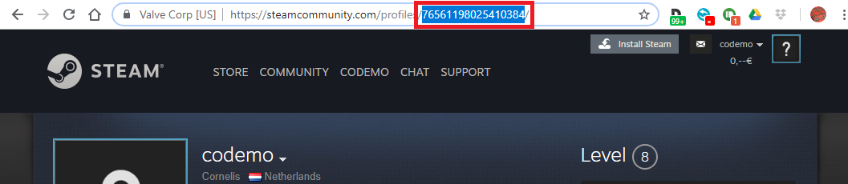

Step 6: Click on “Games”

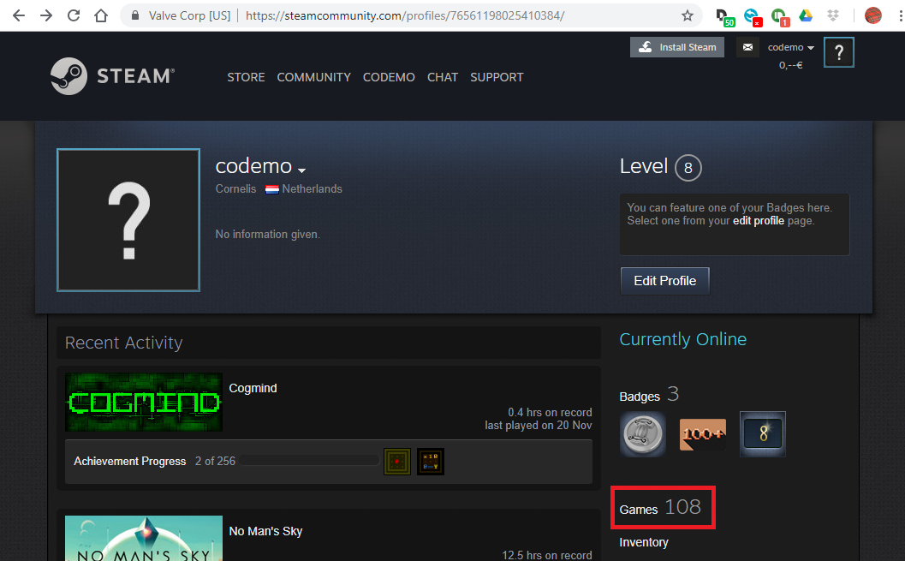

Step 7: For one of your games for which you have achievements, click on “View Stats” and then on “<your username>’s Achievements”

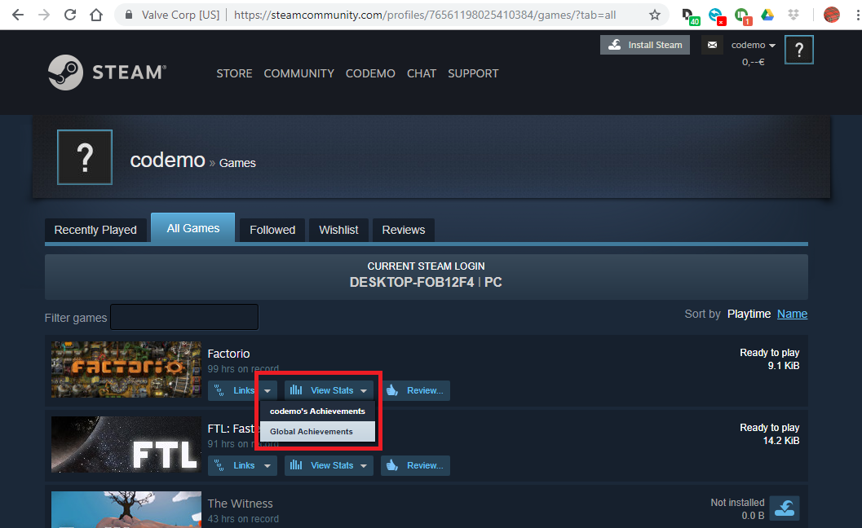

Step 8: Check whether you actually have achievements for this game. Note the app id: in the address bar at the top of your screen, there should be a number in the URL, immediately after “/stats/”. This number is unique for each game. For the example shown here, the app id is 427520.

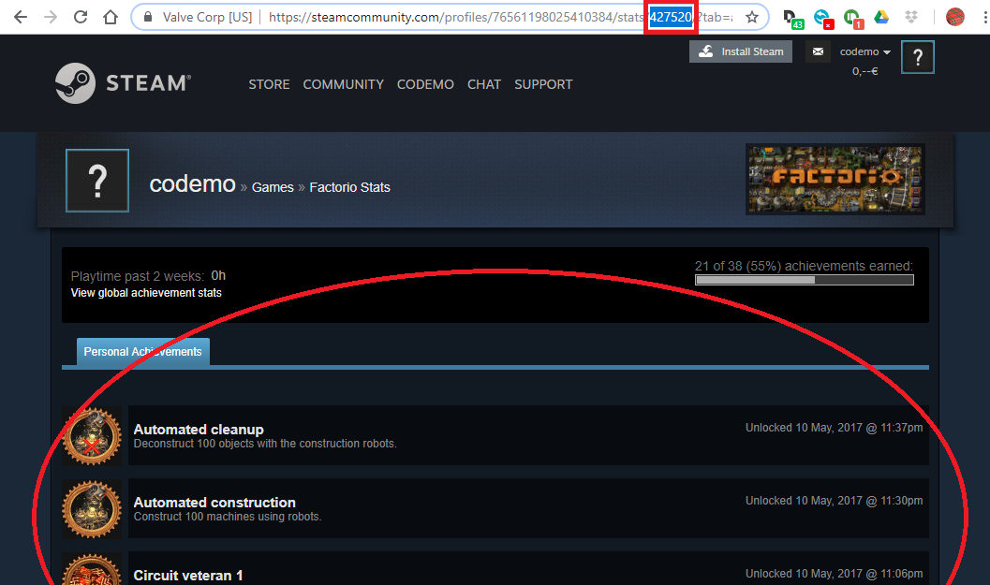

Step 9: Go to Postman and enter a request URL containing the app id, the Steam Web API Key and the 64 bit Steam id. Then, click “Send”. As an example, for me the request URL is: <http://api.steampowered.com/ISteamUserStats/GetPlayerAchievements/v0001/?appid=427520&key=BEDCC4DF8D6E903541324F215814C1D5&steamid=76561198025410384>

If the app id, key and steam id are valid, your achievements for this particular game should appear.

